**CHAPTER 1**

**INTRODUCTION**

**INTRODUCTION**

The use of the Internet and the World Wide Web has revolutionized the provision of information and the facility for the user to take action on the information obtained. Use of the Internet to enable students and companies to manage the placement process with the active involvement of the Placement Coordinator. This led to a unique web-based training and placement management system. Online training and placement management system provides information on placement providers and the placements they offer so that students may view and assess their opportunities.

The "Training and Placement Management System" has been developed to override the problems prevailing in the practicing manual system. This software is supported to eliminate and, in some cases, reduce the hardships faced by this existing system. Moreover, this system is designed for the particular need of the company to carry out operations in a smooth and effective manner.

The application is reduced as much as possible to avoid errors while entering the data. It also provides error message while entering invalid data. No formal knowledge is needed for the user to use this system. Thus, by this all it proves it is user-friendly. Training and Placement Management System, as described above, can lead to error free, secure, reliable and fast management system. It can assist the user to concentrate on their other activities rather to concentrate on the record keeping. Thus, it will help organization in better utilization of resources.

Every organization, whether big or small, has challenges to overcome and managing the information’s of Placement, Training, Colleges, Users, Registration. Every Training and Placement Management System has different Training needs; therefore, we design exclusive employee management systems that are adapted to your managerial requirements. This is designed to assist in strategic planning, and will help you ensure that your organization is equipped with the right level of information and details for your future goals. Also, for those busy executive who are always on the go, our systems come with remote access features, which will allow you to manage your workforce anytime, at all times. These systems will ultimately allow you to better manage resources.

The users can access easily to this and the data can be retrieved easily in no time. In the student registration form, we can give personal details, educational qualifications, and professional skills. The job details of the placed students will be provided by the administrator. The job provider and the placements coordinator to take effective actions on the web as a follow on from the information they have viewed. The administrator plays an important role in our project. He provides approval of student registration and updating

* 1. **PROBLEM DEFINITION**

The existing system is doing all the processes manually. The administrator should refer all the records kept for years ago to simply know details. This so tedious and time consuming. This process is so difficult when the number of users increases. There are a lot of limitations for the existing system. In manual Training and Placement all the work that is done at CMRCET is by human intervention due to which there is a maximum chance of errors. The interface of student and a TPO is maximum which makes the system time consuming. At CMRCET the records are stored in modified access sheets hence sorting is a problem. The files are not stored hierarchical format hence searching is a big problem due to this the updating is very difficult and ambiguous this leads to the duplication of records is usual hence data redundancy; The students are not being made aware of the Training and Placement activity hence there might have been loss of opportunities. The Access sheets were less optimized e.g. suppose we want students having 65% aggregate then the student with 70%, 75% aggregate are also selected whereas required result is only students with 65% aggregate. The system now at CMRCET Training and Placement department could not take acknowledgement from the students attending to particular event hence lots of confusion at the last moment. There are fewer interfaces between student and Training and Placement department. There was no record kept of the past students. There is less communication between past or present student with the Training and Placement department.

**1.2 OBJECTIVE**

The main objective of the placement management system is to reduce manual work and time. It is difficult and time-consuming to collect all the details from each student. To avoid this problem we have planned to develop a web-based placement management system.

* Easy to find out the list of eligible students attending the drives.
* It manages the details of student records, placement training, and different placements happening in and out of the college.
* Saves the time of placement officer and faculties.
* Reduces the manual works.
* This system makes student information more secure.

**1.3 SCOPE**

The project has a wide scope. Our project mainly helps in improving productivity and makes use of utilization of resources. There is no duplication of work as this was not the case when done manually. Thus it reduces labor and increases morale. The system intends user-friendly operations which may resolve ambiguity. The project is a total management and informative system, which provides the up- to-date information of all the students in the college. Our system also help the college to overcome the difficulty in keeping records of hundreds of students and searching for a student eligible for recruitment criteria from the whole thing. It helps in effective and timely utilization of resources. The project facilitates user friendly, reliable and fast management system. The placement officer itself can carry out operations in a smooth and effective manner. They need not concentrate on record keeping. The college can maintain computerized records thus reducing paper work, time and money.

Our project aims at Business process automation, i.e., we have tried to computerize various processes of Training and Placement Management System.

* In computer system the person has to fill the various forms & number of copies of the forms can be easily generated at a time.
* In computer system, it is not necessary to create the manifest but we can directly print it, which saves our time.
* To assist the staff in capturing the effort spent on their respective working areas.
* To utilize resources in an efficient manner by increasing their productivity through. automation.
* The system generates types of information that can be used for various purposes.
* It satisfies the user requirement
* Be easy to understand by the user and operator
* Be easy to operate
* Have a good user interface

**Modules of Training and Placement Management System:**

* Training Management Module: Used for managing the Training details.
* Registration Module: Used for managing the details of Registration
* Users Module: Used for managing the details of Users
* Placement Management Module: Used for managing the information and details of the Placement.
* Company Module: Used for managing the Company details
* Colleges Module: Used for managing the Colleges information’s
* Login Module: Used for managing the login details
* Users Module: Used for managing the users of the system

**CHAPTER 2**

**EXISTING SYSTEM**

**2.1 Existing System**

Existing system does all process has done by manually. Placement officers maintain the information about students manually. If any modifications or updates are required in their profile of any students, it has to be done manually. This is very difficult task for TPO to maintain the student data and company details as it is time consuming, lack of security of data and also it takes more man, etc. This is so difficult to the TPO when number of user's increases.

**2.1.1Problems in existing system**:

* Maximum manual work: in the existing system all the work that is done by human intervention. Humans should do all the work.
* Errors: due to the manual intervention there are maximum chances of errors.
* Maximum human interface: the interface between the student and administrator is maximum.
* Time consuming: due to above problems every procedure becomes time consuming.
* File system: the records were stored in modified access sheets hence sorting problem.
* No hierarchical: the files were not stored hierarchical format hence searching problems.
* Updating records: due to above problems the updating was very difficult.
* Less alertness: the students may not get the information on training and placement activity hence they miss the opportunities.
* Alumni record: the past students records are not maintained

**LINKEDIN:**

LinkedIn is an American business and employment-oriented online service that operates via websites and mobile apps. Launched on May 5, 2003 the platform is mainly used for professionalnetworking, and allows job seekers to post their CVs and employers to post jobs.

LinkedIn allows members (both workers and employers) to create profiles and "connect" to each other in an online social network which may represent real-world professional relationships. Members can invite anyone to become a "connection".

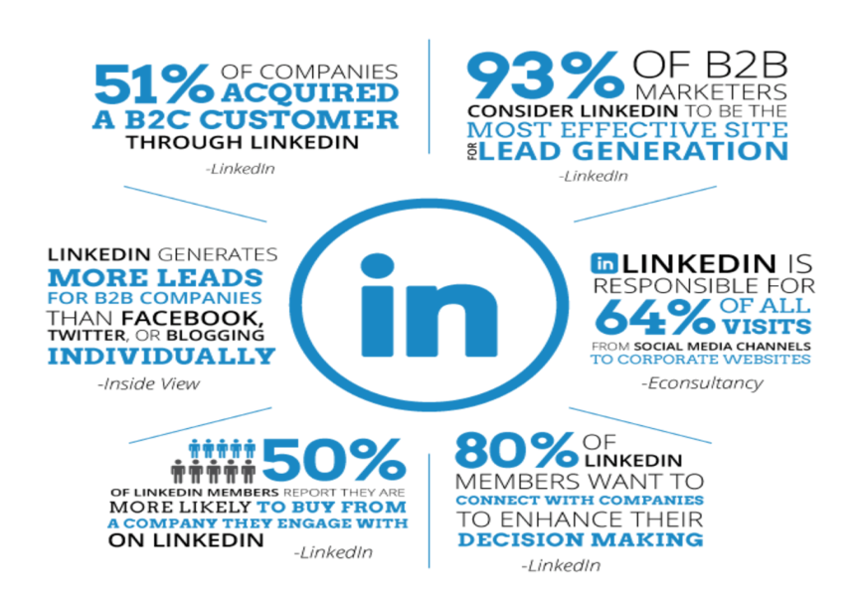

In LinkedIn we can put our work experience on our profile so, potential employers can see it. LinkedIn profile is like an online version of a person’s resume. Allows companies to create profiles to show themselves off, connect with potential partners, and hire new employees. LinkedIn can help in establish and expand professional network. It helps in showing persons

skills /credentials. Its connections can endorse the skills on the list of profile of that particular person. Companies post job listings on LinkedIn and help people to search jobs accordingly.

If a person is interested in running a job, he can create a profile and post information of his business and search for employees. It also helps people in taking a good advice from a person in that particular field in which he wanted. It also has groups in which people of similar jobs or skills can find each other and discuss professional matters that relate their work.

**DISADVANTAGES:**

* Slow reaction time by LinkedIn support. (slow customer service)
* As it is freely accessible to hundreds of millions of users can lead to imbalance.
* LinkedIn own personal data and information.
* It won’t provide employment opportunities to the illiterates.
* Premium accounts on LinkedIn are costly.



Fig: LinkedIn logo

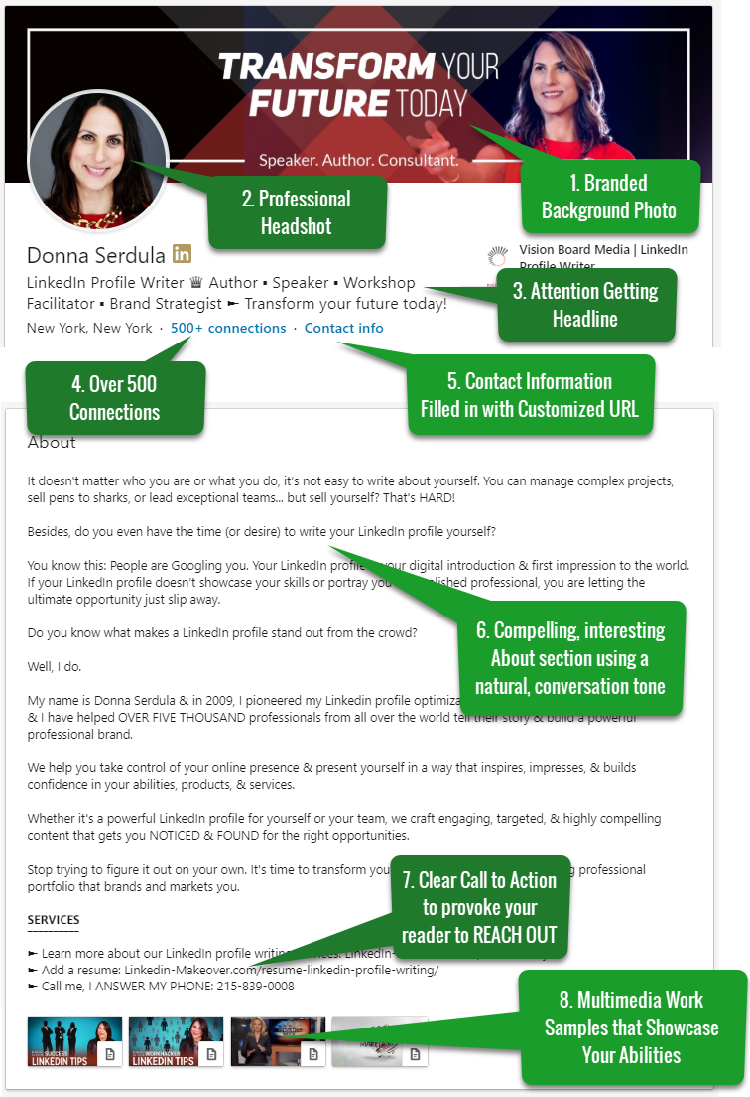

Fig: sample profile in LinkedIn

**INTERNSHALA:**

Internshala is an internship and online training platform. It helps students find internships with Organizations. It is a website of ample of opportunities. we can select our preference or search it to find what we want.

The site offers internship searching and posting, and other career services such as counselling, cover-letter writing, resume building and training programs to students



Internshala can be helpful in providing you with internships of your choice and the best part is Internshala is free of cost for students rather all internships on Internshala (apart from NGO & Not-for-profit organizations) come with a stipend and a certificate.

Its works in three simple ways. Frist a student needs to a registration which is free of cost. Then completing the profile and verifying account. After completing profile student can continue with applying for internships on Internshala that matches profile and availability.

Internshala Trainings also offers 10+ online trainings in the most in-demand industry-relevant skills. These trainings can be done anywhere and anytime at affordable prices. These trainings will help you learn the technical skills required to land an internship and/or a job

.

And this Internshala provides work from home facility to students and made it easy for them. Apart from this training can be given in online mode also. These two facilities are really helpful for students so that their academics does not get affected. It provides favourable working environment and flexible working hours. Internshala also provides certificates it will help the students shape their career.



5

**DISADVANTAGES:**

It lacks internships of big MNCs and brands such as Microsoft, Google, TCS, Wipro, HFDC bank, Reliance etc.

There is only a limited no. internship for 1st year students, who have just stepped into the college life.

International internships, is another grey area which can be improved upon and it would in fact give a major advantage to the traffic on to the website. But even Internshala won’t work on illiterates.

**MONSTER:**

Monster is a global leader in connecting people and jobs. Every day, Monster aims to make every workplace happier and more productive by transforming the way employers and candidates find the right fit.

It is India’s leading online career and recruitment resource with its cutting-edge technology provides relevant profiles to employers and relevant jobs to jobseekers across industry verticals, experience levels and geographies. More than 200 million people have registered on the Monster Worldwide network. Today, with operations in more than 40 countries, Monster provides the widest and most sophisticated job seeking. It Work’s to bring humanity and opportunity to the job market, to enhance lives, businesses and communities around the world.

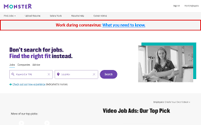

Monster is the largest resume database in the world. Given a choice of the top three for database mining, many recruiters will choose Monster as the best place to post their jobs because it is so well known and is the default for job hunters. For this reason, it is worthwhile for a candidate to post their resumes Monster is very functional. The most unique feature is the ability to block your resume from certain companies. This is beneficial if you're currently employed and looking for a new job, but don't want your current employer to know you're on the hunt. Monster also offers incredibly advance filtering options and a helpful resource center.

**INDEED:**

Indeed is the no.1job site in the world with over 25 crore unique visitors every month. Indeed strives to put job seekers first, giving them free access to search for jobs, post resumes, and research companies. Every day, it connects millions of people to new opportunities**.**Indeed offer great sponsored options for employers looking to go farther and wider in their search for the perfect candidate. Indeed changed the way that business was conducted which resulted in a definite improvement for job seekers who were using the browser to find potential jobs. They implemented a system by which job seekers could post their resumes and store them on the Indeed.com site and they could apply directly to the jobs that they were interested in through the site. This added a big convenience for job seekers.

Independent research shows indeed delivers three times as many hires as monster, LinkedIn and career builder. Indeed gives you access to the largest pool of job seekers online even if we don’t have a company career site it costs nothing to post and takes just a few minutes go to indeed.com and create your employer account, post a job and search for job.



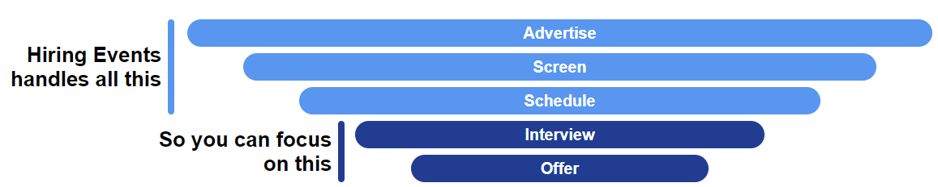50It allows you to post a job in five minutes. Gets the candidate job Sponsored to Attract More Candidates The job site features a detailed dashboard to help you manage your candidates with great ease. Job applicants will send their interest via emails and it may become difficult for you to manage everything at its best. It helps in Finding the Right Fit for Mentioned Profile. This can help in driving more people to your jobs and helps in converting them as candidate potential employees. Candidate can use Indeed Resume service to find the exact candidates by mentioning the skills and experience that he has been looking for.

**DISADVANTAGES:**

* The site is designed to find job seekers work and employers’ employees, but it definitely doesn’t want things to work out for long.
* Indeed favors quantity over quality.
* Applications process is not Streamlined:

Due to the fact that this website pulls its vast job listings from countless Sources, users may find themselves constantly being redirected towards

Other search sites just for them to start applying, which means that there is no one-click application process.

**2.1.5. GLASSDOOR:**

Glassdoor is a website where current and former employees anonymously review companies. Glassdoor also allows users to submit and view salaries as well as search and apply for jobs on its platform. Glassdoor offers millions of the latest job listings, combined with a growing database of company reviews, CEO approval ratings, salary reports, interview reviews and questions, benefits reviews, office photos and more.



Fig: Glass door logo

Glassdoor is a job board and employer review site that allows employers to post jobs through their partner site Indeed. It also allows employees to post reviews of employers and salary information, and employers to manage their profiles on the site Employees can edit reviews that have been posted within the last 30 days if the employer has not responded to it. Employers cannot remove them, but can flag them if they think there are issues, and Glassdoor can review them.

If your company has a lot of Glassdoor reviews it shows that people who work for you use it. If the ratings are positive, it makes sense to leverage those reviews and post your jobs on Glassdoor through the Indeed posting platform.

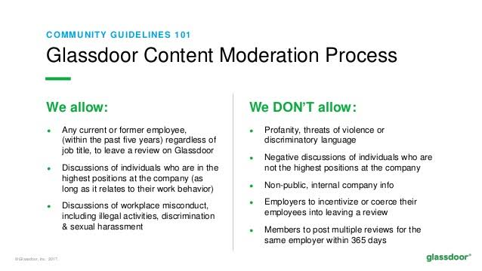

GLASSDOOR has changed the way people look for jobs. It has roughly 30 million unique users visiting in mobile applications and website monthly. The site has a data base of more than 540,000 companies, where employees and job seekers can leave reviews on everything from the interview. some companies look at Glassdoor as just a place for disgruntled employees to complain. But employers can Benefit from using glass door as well. Using Glassdoor, job seekers and employees have access to lots of information they might not otherwise have, such as salaries, interview questions, employee satisfaction levels…. etc.

As every candidate wants to feel safe, Glassdoor don't allow employers to access candidate personal information without candidate permission, and they never share any anonymous insights (i.e., reviews, ratings, salary reports, office photos) that candidate have shared on Glassdoor. ... candidate can add, remove, or edit information on your profile at any time.

**DISADVANTAGES:**

* There's No Employee Verification System**.**
* It won’t focus on providing job opportunities to the illiterates.
* People Tend to Write Reviews When They've Had a Negative Experience.
* The Ratio of Reviews to Employees is Unreliable.

**GAPS IN EXISTING SOLUTIONS:**

All the existing solutions have many disadvantages. The **following** are the gaps we found in those existing solutions:

* It’s Informal

(For some roles, companies perceive that online job postings – particularly on social media – can give off the wrong image of their company)

* It Attracts Fraudulent Applicants

(Some applications might be fake, in order to get information about the company or hiring officer)

* It Can Be Difficult to Measure Effectiveness

(Not all online recruitment services offer an in-depth analysis of your posting; therefore, it can be hard to figure out what is and isn’t working and how to optimize your ad.)

* Searching for jobs in these online websites can be useful for graduate or professional but not illiterate people. There are many illiterate people finding difficult for finding a job.

**CHAPTER 3**

**PROPOSED METHOD**

**3.1 OVERVIEW OF PROPOSED METHOD**

The proposed Online Training and Placement System management system meant to give more easiness to the users that they can add and retrieve information so quickly.

There are mainly three types of users they are administrator, student and HR. The administrator is the master user; he gets the most number of priorities than the other users. The different functions involve the case of an administrator are updating, approval, sending information to the students regarding placements. The administrator can view and approve the various application forms. Students can register and view the details. The placement officer can login through HR section view the details of the HR’s, placed students, and training details.

The proposed online training and placement management system is intended to avoid all the drawbacks of existing system. It will add some more features than the existing system. The proposed system is a cost effective way of doing the manual processes done in the existing system. This helps the AMCEC (AMC Engineering College) organization to win the war in the existing competitive world. The proposed system is intended to do the following:

* Online Registration: Traditionally the job of registration was done manually at AMCEC by passing the registration form to the students. But this was too much time consuming and also erroneous. So the major need was for the automation for registration by online registration by students themselves.
* Security For Administrator: The files in which the data is stored is stored in Access file sheets that too separately for each class of department; so the files could be accessed by any one accessing the computer. These files may be ‘confidential’. So there is a special need for security. Optimized Sorting of data: The modified access sheets were not that efficient as, when we want to select students having 65% aggregate then the student with 70%, 75% aggregate were also selected where as required result is only students with 65% aggregate.
* Hierarchical Structure of departmental data: As mentioned earlier the data was stored separately for classes of each department the problem of searching was time consuming and as well the duplication could occur. So there is a need for a centralized hierarchical structure.
* Instant Notification to the student: The only method for notification until now is by notice board which is not reliable. To countermeasure this problem the notification can be send by E-mail and mobile SMS.
* Alumni Data Base: The alumni data is insufficient and is out of reach of the students. So, the proper method to employed to store the alumni data.
* Training and placement department maintains the details of each student.
* Students can view the status of their upcoming campus.
* Search feature helps to admin because they check particular student is present or not
* Admin can only update student details and academic records like email id, current semester, correspondence address and marks obtained in different semesters via csv file.
* Provides a proper communication channel between student and training & placement department using the Sms.
* Latest information about which company is visiting the campus is provided in the website which helps the students to get updated information quickly.
* Website is user friendly with more GUI so that student view the information easily.
* Duplicate registrations can be avoided and hence it provides reliability.
* Only administrator can modify the Placement and organization record if needed. •
* Website more helps to make a short list of students who get placed in certain Company and who is unplaced. student can manage passwords, access technical papers and view eligibility criteria for on-going recruitments. Coordinators maintaining the attendance records of CRT classes.

**3.2 Requirement Analysis**

Here we have used HARDWARE & SOFTWARE products for the completion of project and there are User Requirements & Project Requirements.

**3.2.1 Backend Technology:**

**Django** is a free and open-source web application framework, written in Python. It is a server-side web framework that provides rapid development of secure and maintainable websites.

Django is a high-level Python's web framework which was designed for rapid development and clean, realistic design.

Django follows Model-View-Template (MVT) architectural pattern.

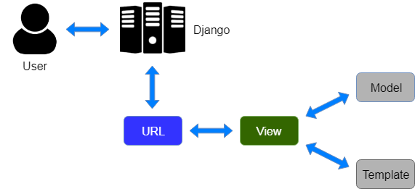

Here, a user **requests** for a resource to the Django, Django works as a controller and check to the available resource in URL.

If URL maps, **a view is called** that interact with model and template, it renders a template.

Django responds back to the user and sends a template as a **response**.

**Django follows MVT (Model View Template) pattern.**

**Model:** It is the data access layer. It contains everything about the data, i.e., how to access it, how to validate it, its behaviors and the relationships between the data.

**View:** It is the business logic layer. This layer contains the logic that accesses the model and defers to the appropriate template. It is like a bridge between the model and the template.

**Template:** It is a presentation layer. This layer contains presentation-related decisions, i.e., how something should be displayed on a Web page or other type of document.

**Models.py file:** This file defines your data model by extending your single line of code into full database tables and add a pre-built administration section to manage content.

**Urls.py file:** It uses a regular expression to capture URL patterns for processing.

**Views.py file:** It is the main part of Django. The actual processing happens in view.

**Features available in Django web framework are:**

* Admin Interface (CRUD)
* Templating
* Form handling
* Internationalization
* A Session, user management, role-based permissions
* Object-relational mapping (ORM)
* Testing Framework
* Fantastic Documentation
* Embedded SQLite Database

**3.2.2** **Front End Technology**

* 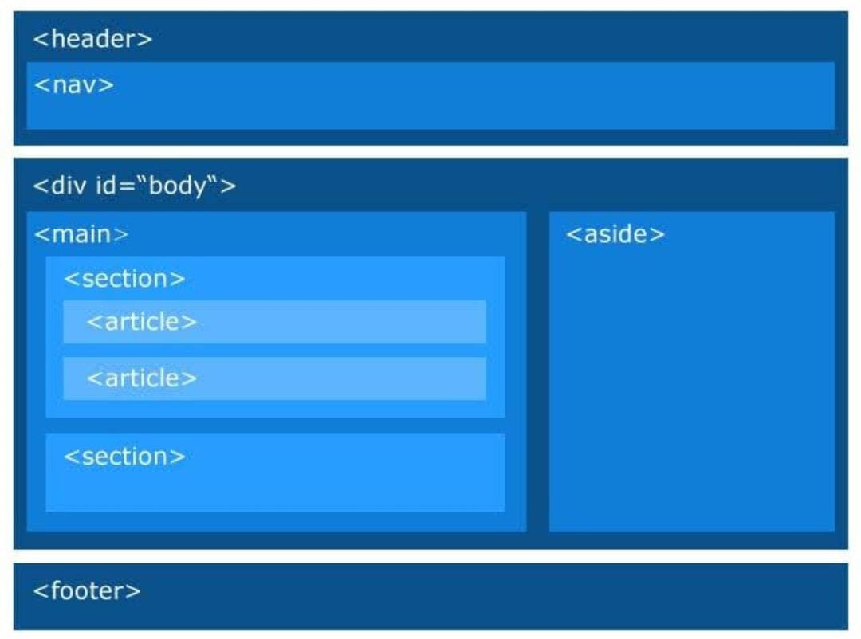**HTML**: Hypertext Mark-up Language (HTML) it is used to give the content and to create the web development and It act as a structure of a web page.

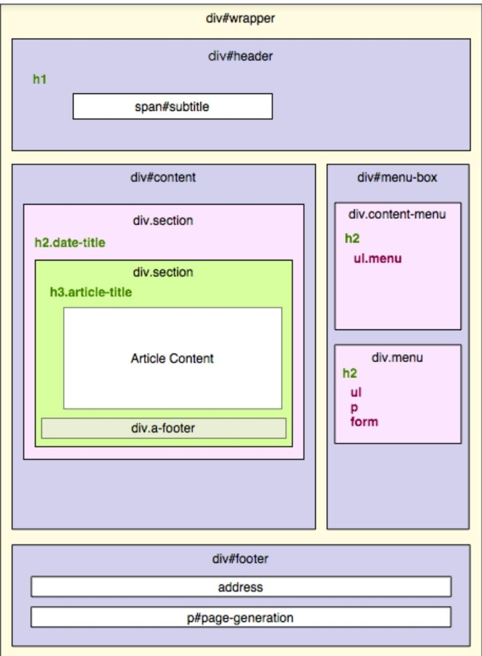**CSS**: Cascading Style Sheet creates attractive layout and design of a web page.

**Bootstrap**: Bootstrap is the most popular HTML, CSS and JavaScript framework for developing responsive, mobile-first websites.

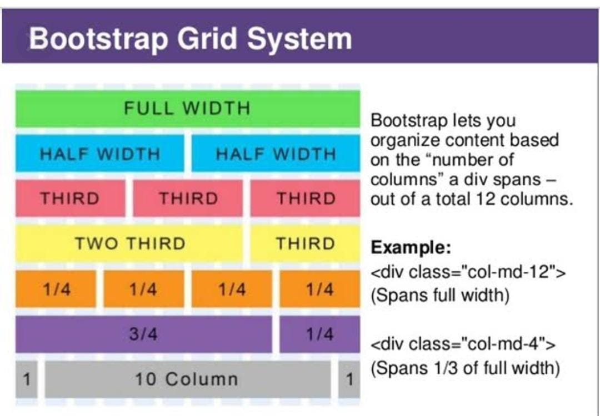

**Hardware Specifications**

**Operating System**: Window 7 and above.

**Processor:** Pentium Core and above.

**Ram**: 1 GB.

**Hard Disk Space**: 5 GB.

**User Requirements**

Every user should be***:***

* Comfortably work with Computer, Mobile, Tab etc.
* He must also have basic knowledge of English.
* A Browser with good Internet.

**3.3 SYSTEM ARCHITECHTURE**

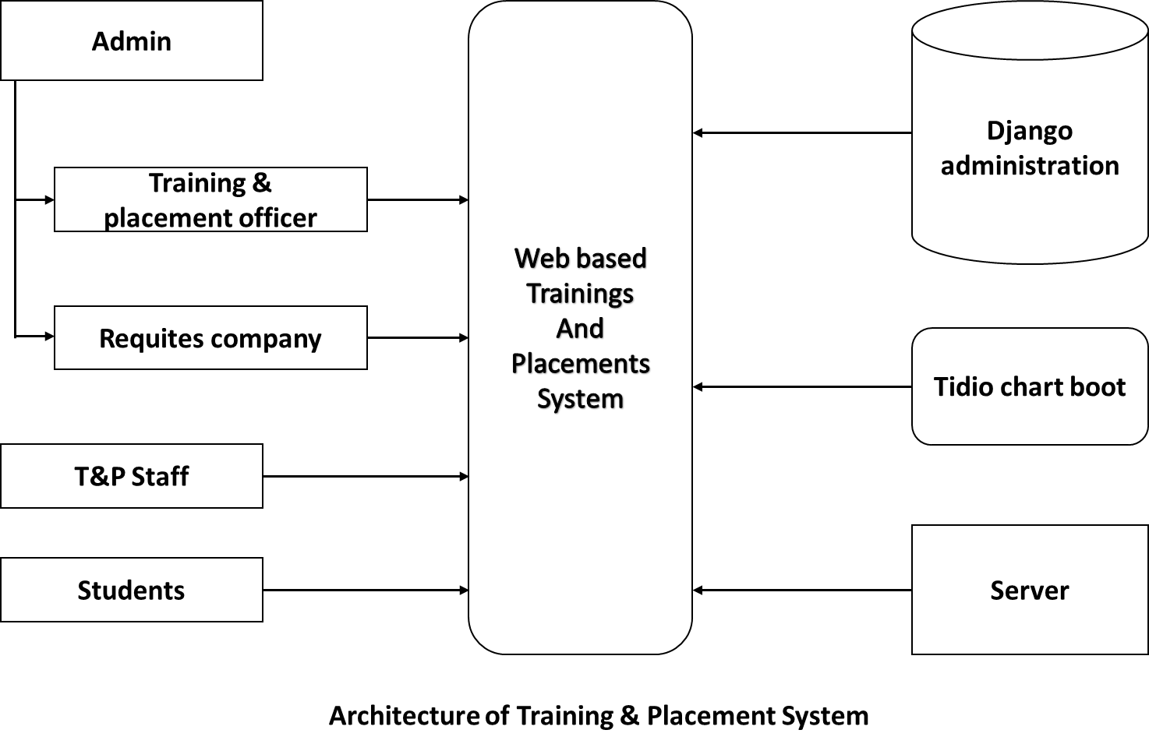

Web Based Training and Placement System:  is a centralized system where TPO, TP Staff, Student, Alumni are the users of the system.

* **Students**

Students are the main component of the system according to the company criteria students. To participate in the placement.

* **TPO**

TPO is the main Admin and having overall control on the system.

* **TP Staff**

These are the staff members of every department which are members of the system.

* **Alumni**

These are students who passed out from the institute but further they are eligible for the placement procedure.

**3.4 SOURCE CODE**

**Manage.py**

#!/usr/bin/env python

"""Django's command-line utility for administrative tasks."""

import os

import sys

def main():

"""Run administrative tasks."""

os.environ.setdefault('DJANGO_SETTINGS_MODULE', 'T2P.settings')

try:

from django.core.management import execute_from_command_line

except ImportError as exc:

raise ImportError(

"Couldn't import Django. Are you sure it's installed and "

"available on your PYTHONPATH environment variable? Did you "

"forget to activate a virtual environment?"

) from exc

execute_from_command_line(sys.argv)

if __name__ == '__main__':

main()

**Urls.py**

from django.contrib import admin

from django.urls import include, path

from django.views.generic import TemplateView

urlpatterns = [

path('admin/', admin.site.urls),

path('',include('application.urls')),

path('accounts/',include('allauth.urls')),

path('cart/',TemplateView.as_view(template_name='dashboard/cart.html'),name='cart'),

]

Application.models.py

from django.db import models

# Create your models here.

class Trainingregister(models.Model):

sno=models.AutoField(primary_key=True)

name=models.CharField(max_length=30)

course=models.CharField(max_length=30)

study=models.CharField(max_length=40)

age=models.CharField(max_length=10)

seats=models.IntegerField()

duration=models.CharField(max_length=50)

location=models.CharField(max_length=60)

date=models.DateField()

link=models.CharField(max_length=100)

def __str__(self):

return self.name

class Placementregister(models.Model):

sno=models.AutoField(primary_key=True)

name=models.CharField(max_length=30)

job=models.CharField(max_length=50)

location=models.CharField(max_length=100)

study=models.CharField(max_length=50)

experience=models.CharField(max_length=60)

salary=models.IntegerField()

startdate=models.CharField(max_length=50)

link=models.CharField(max_length=100)

def __str__(self):

return self.name

**reachUs.html**

{% load static %}

<!DOCTYPE html>

<html lang="en">

<head>

<meta charset="UTF-8">

<meta name="viewport" content="width=device-width, initial-scale=1.0">

<title></title>

<link rel="stylesheet" href="https://cdnjs.cloudflare.com/ajax/libs/font-awesome/5.13.0/css/all.min.css">

<link rel="stylesheet" href="{% static 'css/contact.css' %}">

</head>

<body style="background-image:url('{% static 'images/bg.png' %}')">

<div class="contact-page">

<h2>Get in touch</h2>

<div class="contact-info">

<div class="item">

<i class="icon fas fa-home"></i>

Hyderabad, India

</div>

<div class="item">

<i class="icon fas fa-phone"></i>

+91 9014981598

</div>

<div class="item">

<i class="icon fas fa-envelope"></i>

t2p@gmail.com

</div>

<div class="item">

<i class="icon fas fa-clock"></i>

Mon - Fri 8:00 AM to 6:00 PM

</div>

<a href="/"><button class="btn3">Back</button></a>

</div>

<h3 >Chart with us and<br> clear your querys</h3>

<script src="//code.tidio.co/s3gsqosvt7lodbnk1fxq3k0qjrtu4wbp.js" async class="tidio"></script>

</div>

</body>

</html>

**Login.html**

{% load static %}

<!doctype html>

<html lang="en">

<head>

<meta charset="utf-8">

<meta name="viewport" content="width=device-width, initial-scale=1">

<title>Tech Login</title>

<link rel="stylesheet" href="{% static 'css/login.css' %}">

<link rel="stylesheet" href="https://stackpath.bootstrapcdn.com/bootstrap/4.3.1/css/bootstrap.min.css">

<link rel="stylesheet" href="https://stackpath.bootstrapcdn.com/font-awesome/4.7.0/css/font-awesome.min.css">

<link href="https://cdn.jsdelivr.net/npm/bootstrap@5.0.1/dist/css/bootstrap.min.css" rel="stylesheet" integrity="sha384-+0n0xVW2eSR5OomGNYDnhzAbDsOXxcvSN1TPprVMTNDbiYZCxYbOOl7+AMvyTG2x" crossorigin="anonymous">

</head>

<body>

<section id="nav-bar">

<nav class="navbar navbar-expand-lg navbar-light">

<a class="navbar-brand"><img src=" {% static 'images/logo.png' %} "></a>

<button class="navbar-toggler" type="button" data-toggle="collapse" data-target="#navbarNav" aria-controls="navbarNav" aria-expanded="false" aria-label="Toggle navigation">

<i class="fa fa-bars"></i>

</button>

<div class="collapse navbar-collapse" id="navbarNav">

<h2> Login Page</h2></div>

<div class="collapse navbar-collapse" id="navbarNav">

<a href="/"><button class="btn2">BACK</button></a>

</div>

</nav>

</section>

<!--form-->

<section id="banner">

<div class="container">

<div class="row">

<!---left side one-->

<div class="col-md-6">

<div class="form">

<p class="title"><br><u>Login Here</u></p>

<form method "POST" >{% csrf_token %}

<div class="form-group">

<input type="text" placeholder="Enter Mobile" class="form-control" name="mobile" id="" required>

</div>

<div class="form-group">

<p>Don't have account? <a href="/register">Register!</a></p>

<button class="btn2 ">Submit</button>

</div>

</div>

</div>

<!--right side one-->

<div class="col-md-6 text-center">

<img src=" {% static 'images/kisscc0-laptop-user-personal-computer-computer-icons-male-computer-user-4-5b3da33f034e09.9723889515307661430136.png' %} " class="img" >

</div>

</div>

</div>

<img src=" {% static 'images/smaller-water-texture.png' %} "class="bottom-img">

</section>

</body>

</html>

**Training.html**

<!DOCTYPE html>

<html>

<head>

<link rel="stylesheet" href="{% static 'css/skewed.css' %}">

<link rel="stylesheet"href="https://stackpath.bootstrapcdn.com/font-awesome/4.7.0/css/font-awesome.min.css">

<meta name="viewport" content="width=device-width,initial-scale=1, maximum-scale=1, user-scalable=no">

</head>

<body>{% for event in training%}

<div class="container">

<div class="col-md-4 service">

<div class="box">

<div class="content">

<div class="icon">

<i class="fa fa-code"></i>

</div> <!--

<h2>01</h2>

<h3>Company Name</h3>

<p>Training Details which was entered by the company will visible here</p>

-->

<h3>{{event.name}}</h3>

<p><u>Course:</u><br>{{event.course}}<br>

<u>Location:</u> {{event.location}}<br>

<u>Qulification:</u> {{event.study}}<br>

<u>Avil Seats:</u> {{event.seats}}<br>

<u>Duration:</u> {{event.duration}}<br>

<u>Date:</u> {{event.date}}</p>

<a href="{{event.link}}"><button class="btn2">Register</button></a>

</div>

</div>

</div>

</div>{% endfor %}

<!-- <div class="box">

<div class="content">

<div class="icon">

<i class="fa fa-android"></i>

</div>

<h2>02</h2>

<h3>Company Name</h3>

<p>Training Details which was entered by the company will visible here</p>

</div>

</div>

<div class="box">

<div class="content">

<div class="icon">

<i class="fa fa-database"></i>

</div>

<h2>03</h2>

<h3>Company Name</h3>

<p>Training Details which was entered by the company will visible here</p>

</div>

</div>

<div class="box">

<div class="content">

<div class="icon">

<i class="fa fa-object-ungroup"></i>

</div>

<h2>04</h2>

<h3>Company Name</h3>

<p>Training Details which was entered by the company will visible here</p>

</div>

</div>

-->

<div>

<a href="/"><button class="btn2">Back</button></a><p><font color="white"><b><u>Trainings</u></b></font color></p>

</div>    </body>

**CHAPTER 4**

**RESULTS**

**4.1 RESULTS**

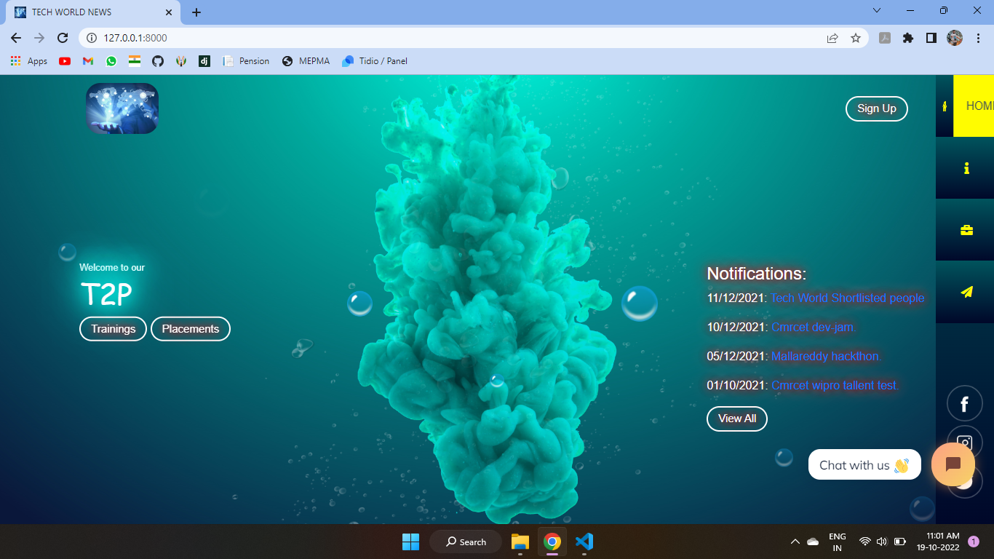

Fig-1: *Main page*

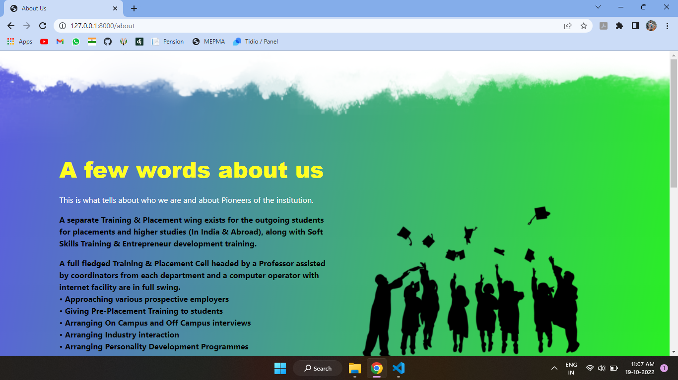

Fig-2: *About TOP*

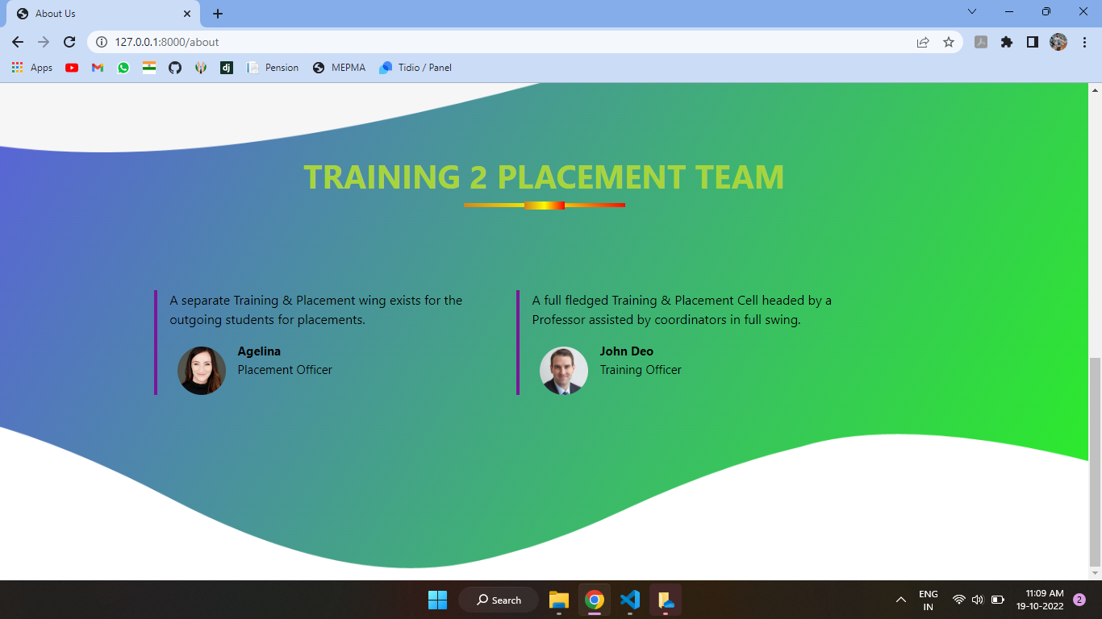

Fig-3: *Trainer’s info*

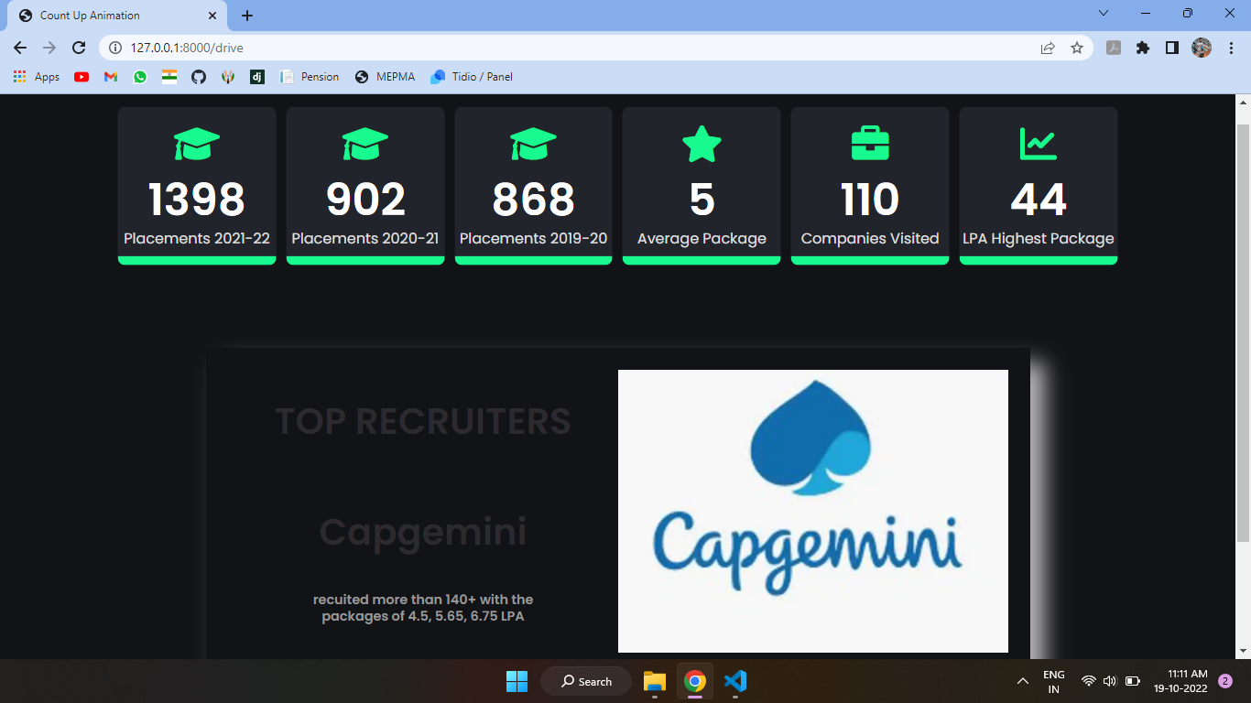

Fig-4:*Placements Statistics*

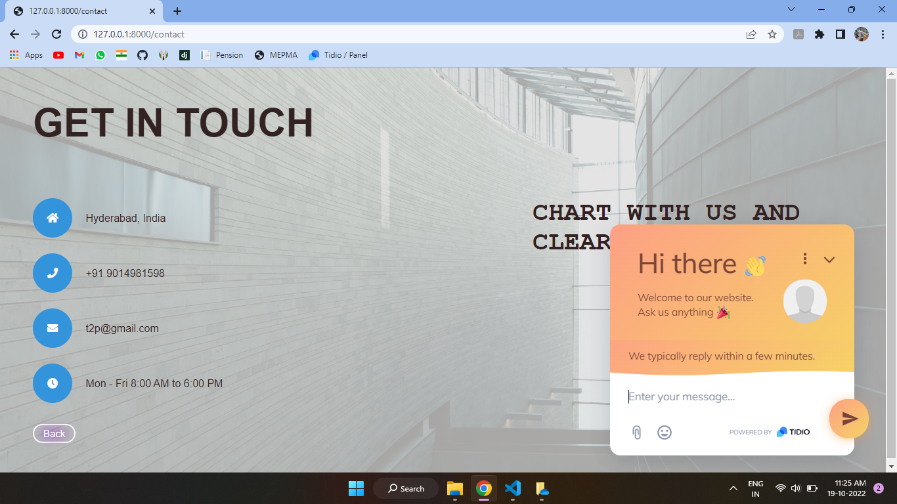

Fig-5 : *Contact us page*

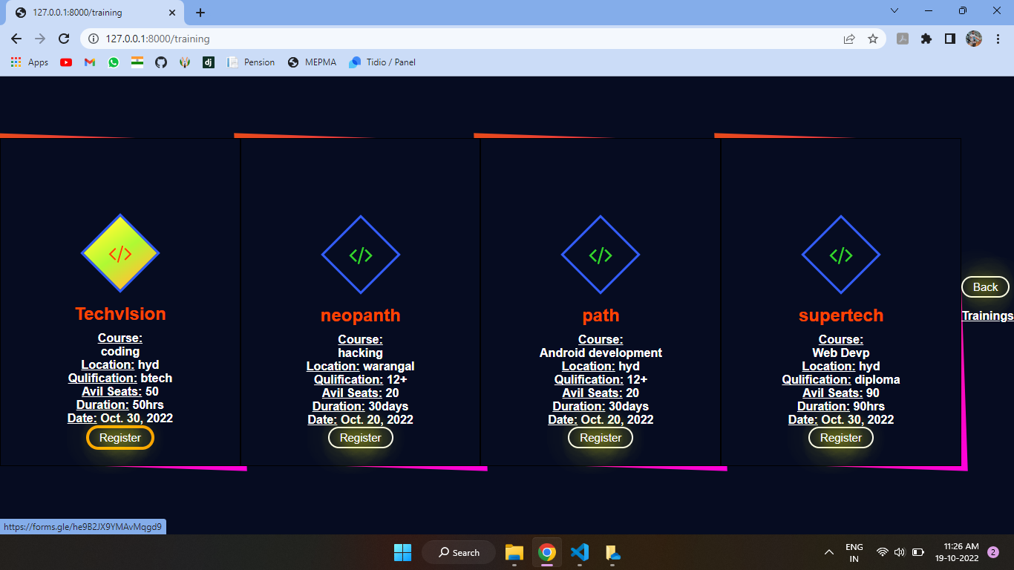

Fig-6 :*Tranings info page*

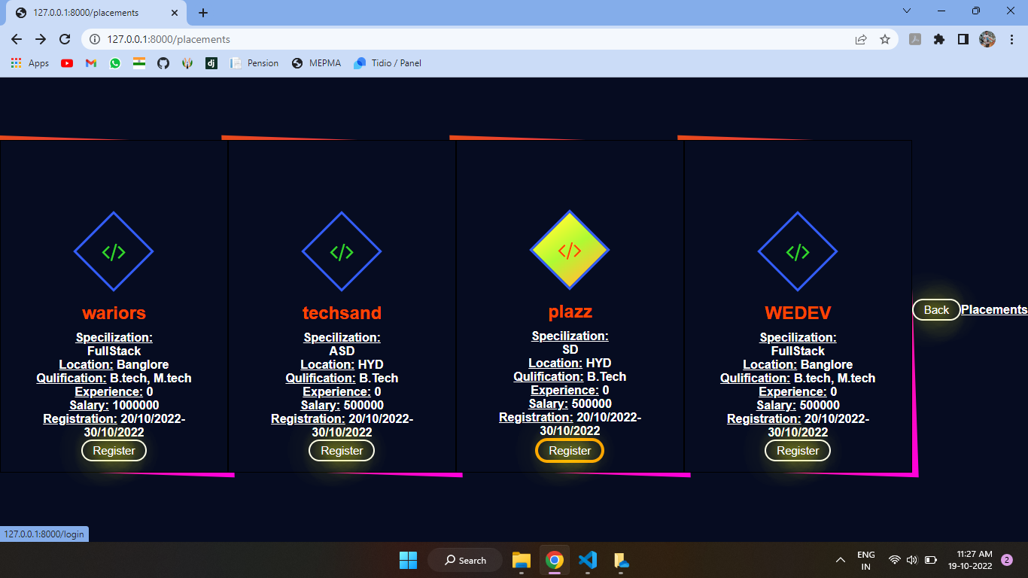

Fig-7 : *Placements info page*

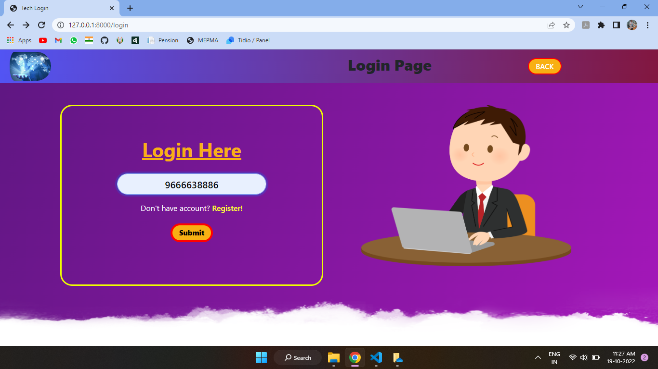

Fig-8 :*Student login*

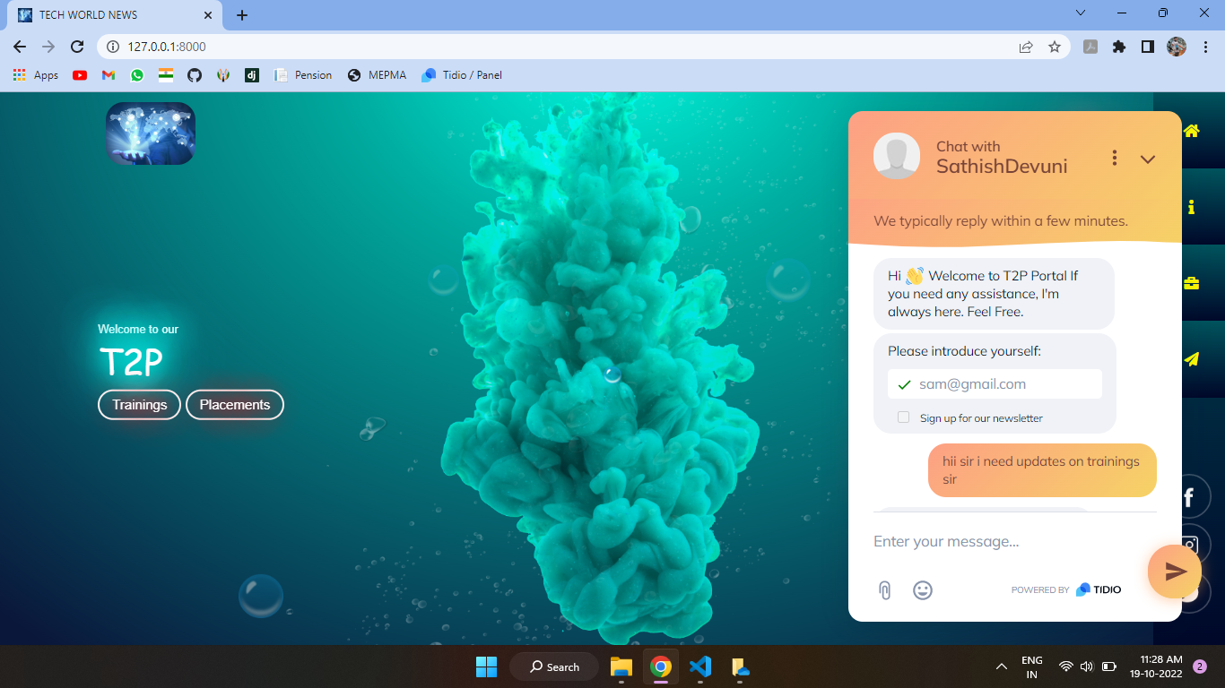

Fig-9 : *Chat-bot support for queries*

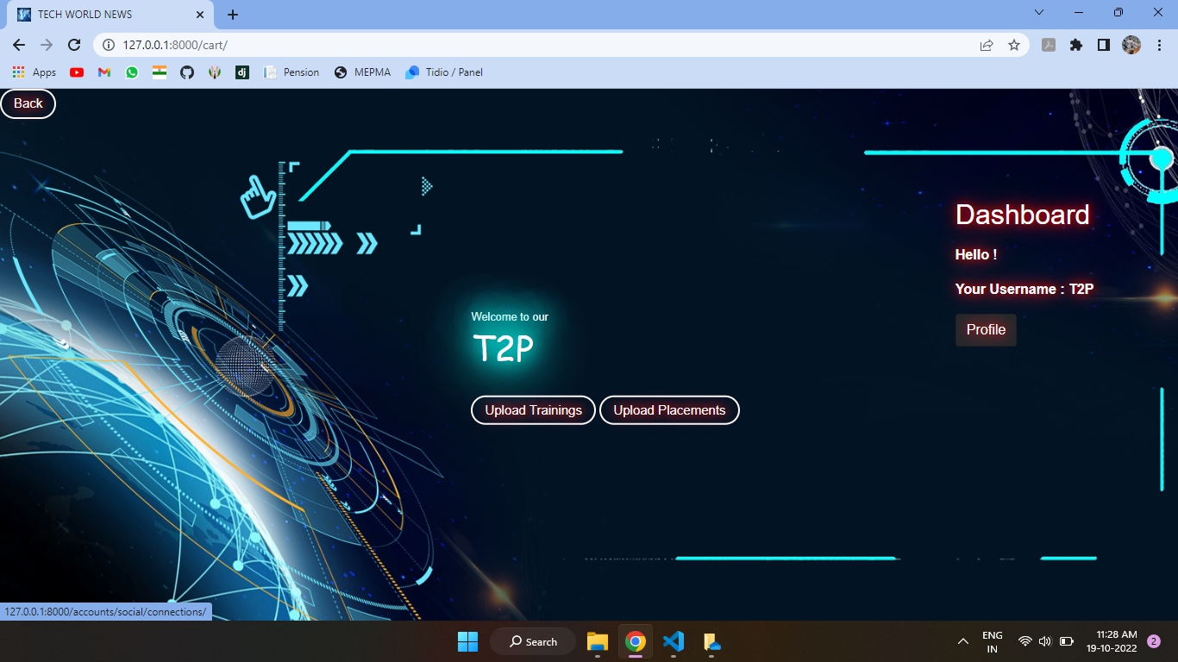Fig-10: *Admin page*

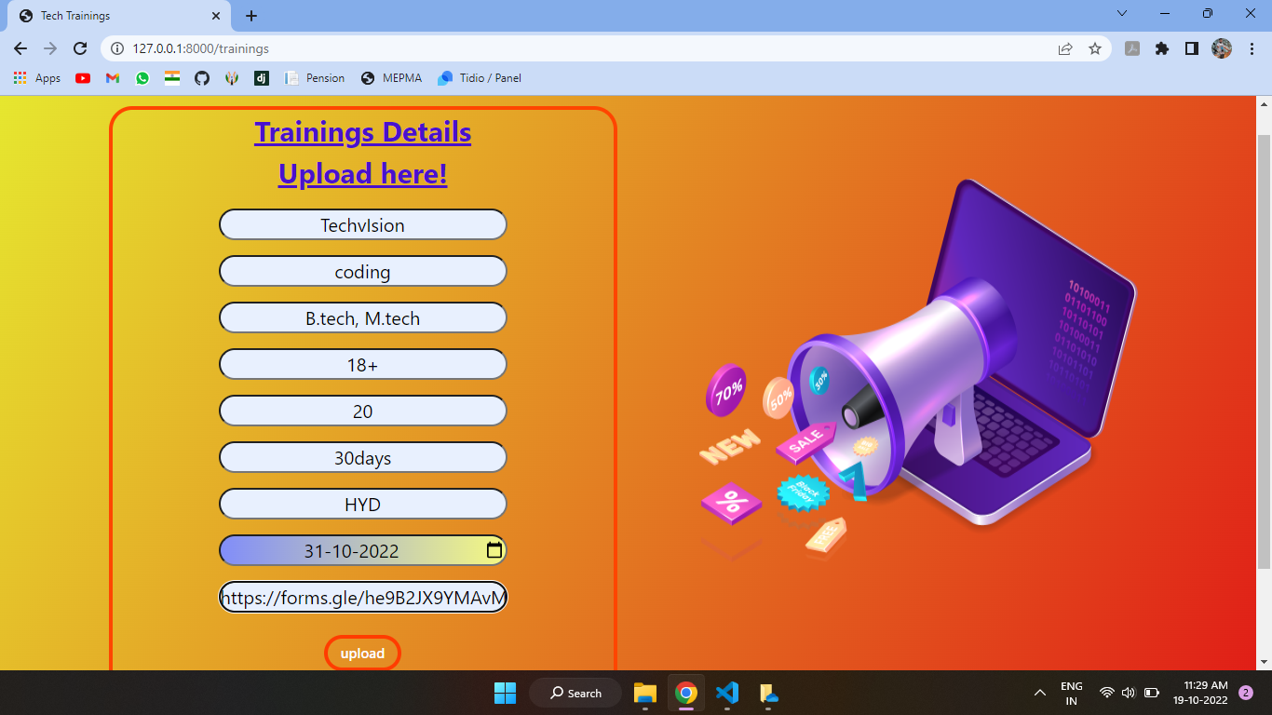

Fig-11: *Updating new Drive info*

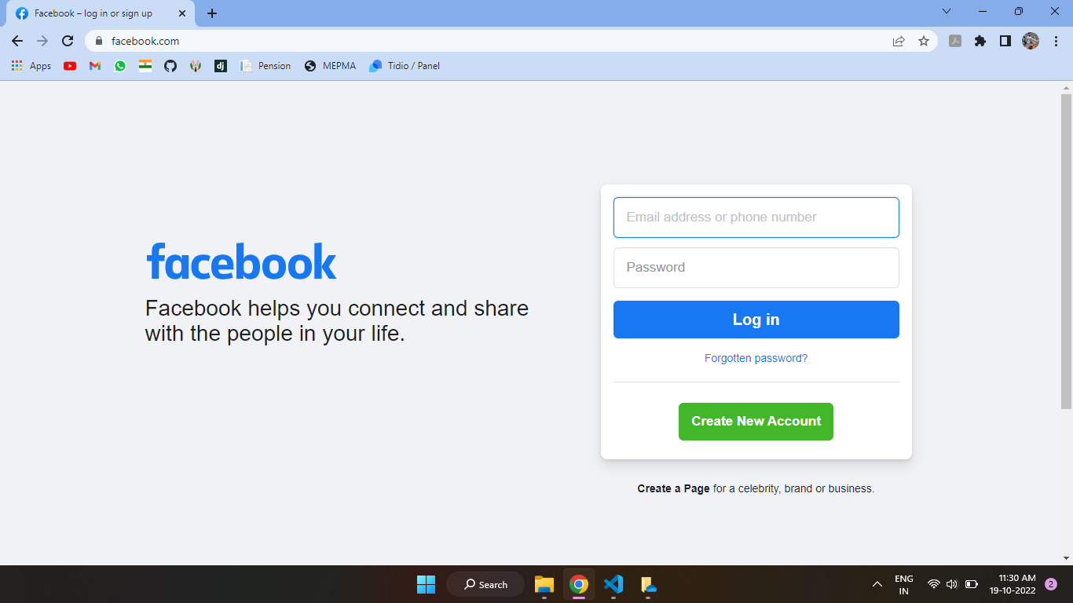 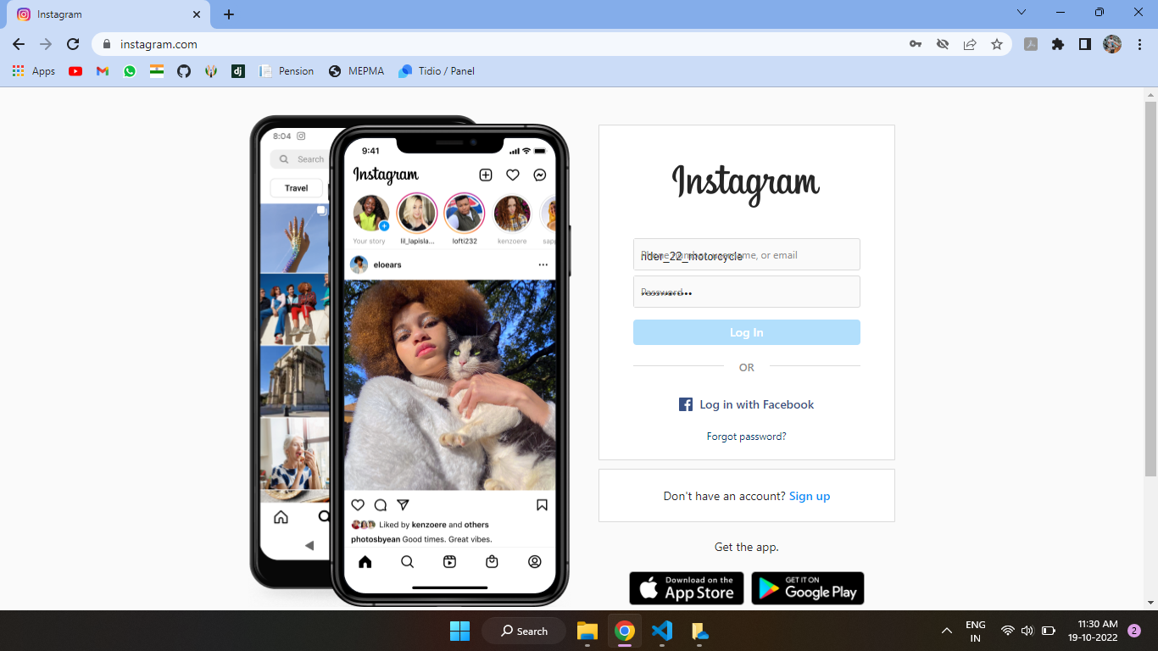

Fig-12: *Social media*

**Admin Interface Screenshots:**

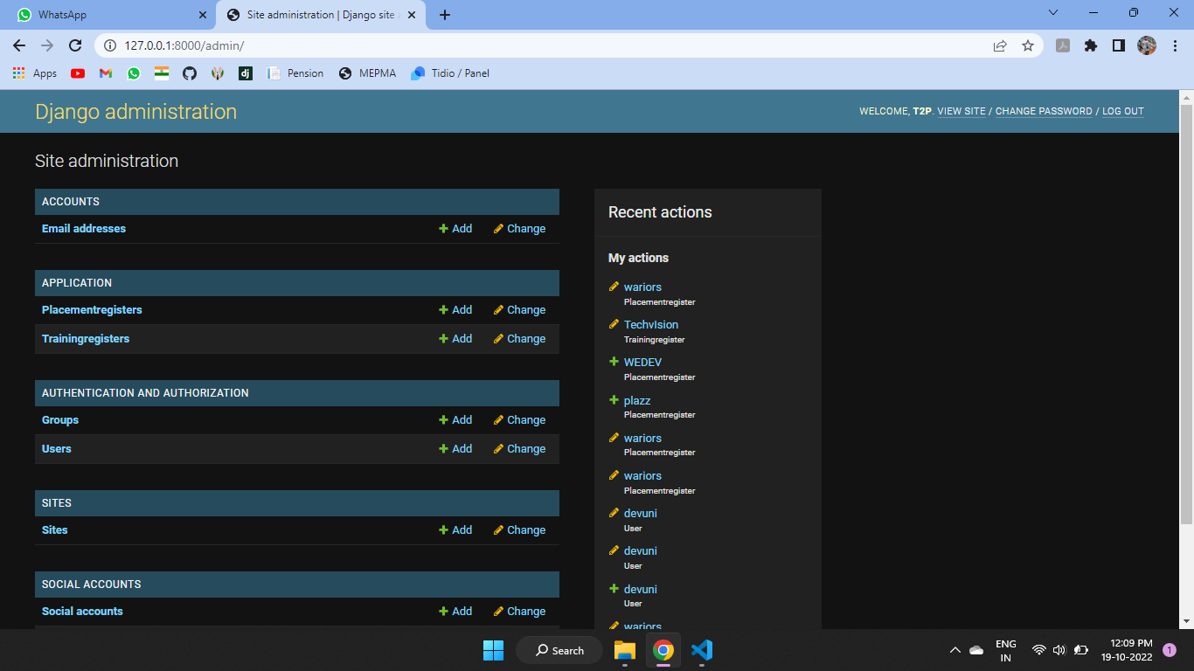 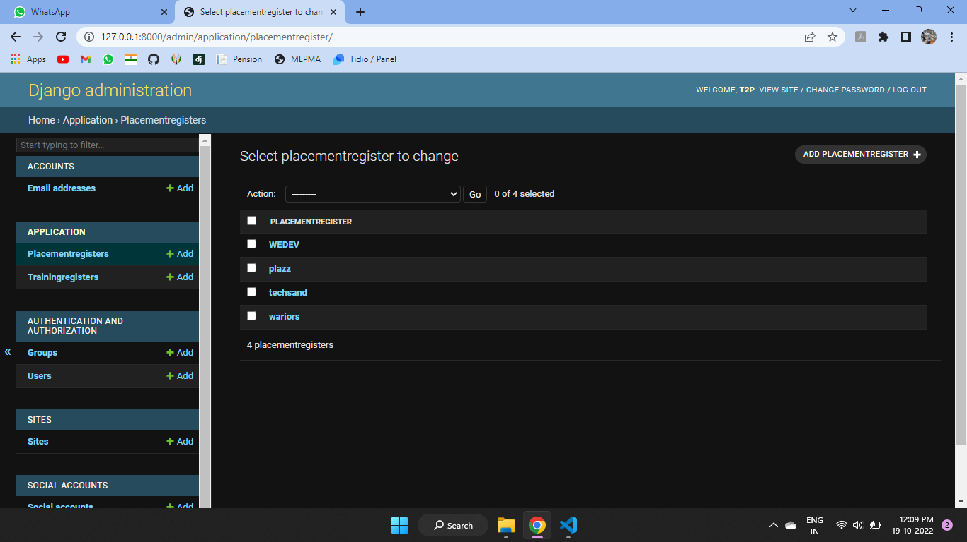

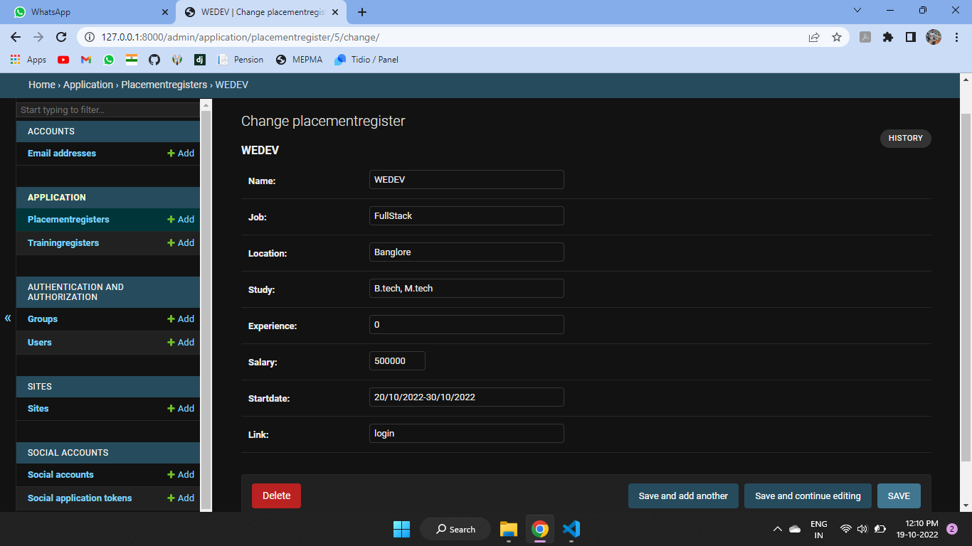 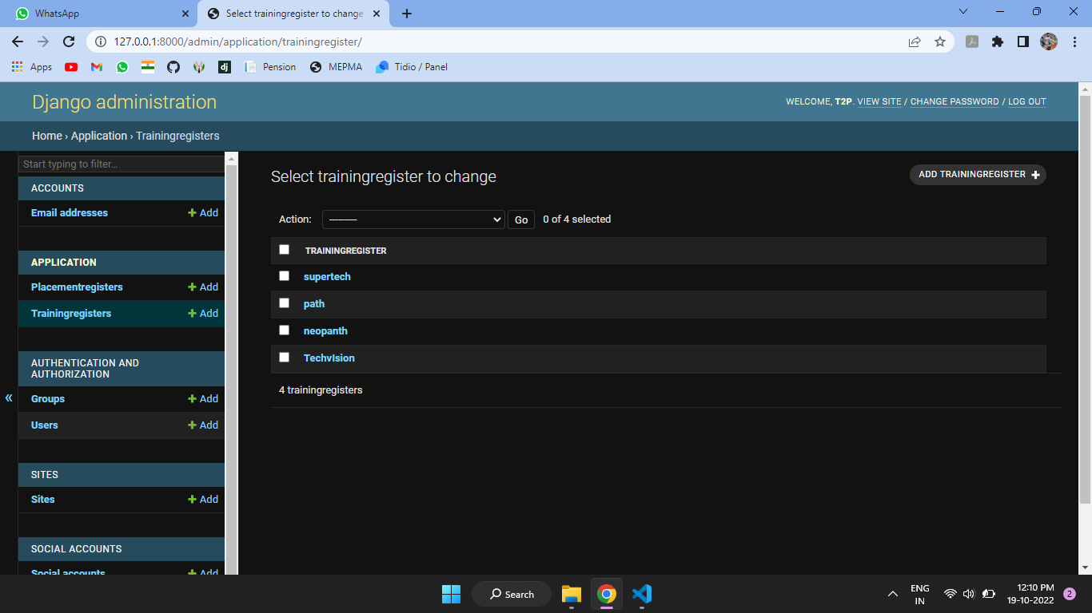

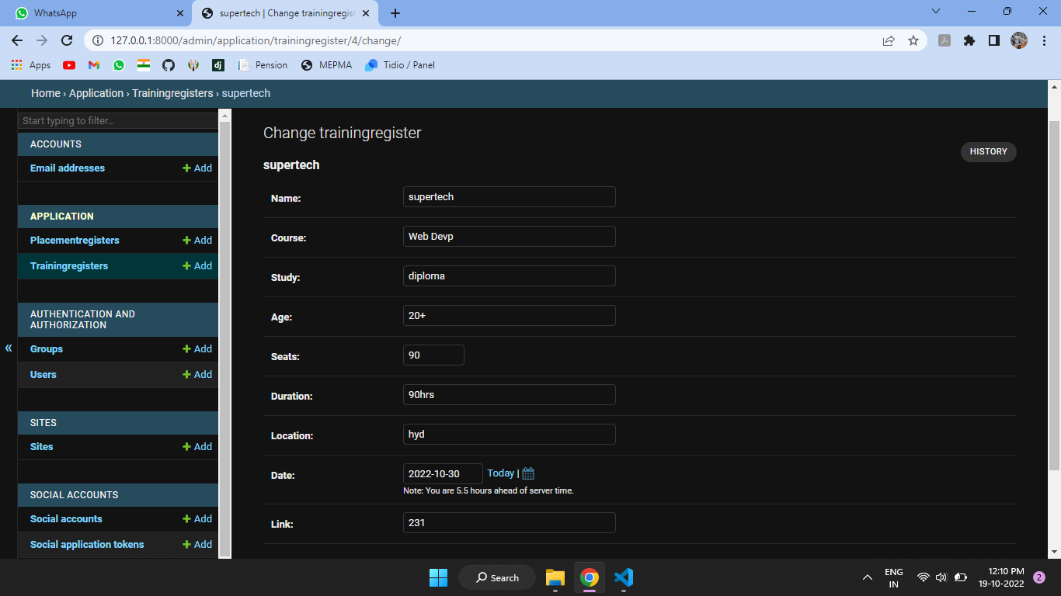 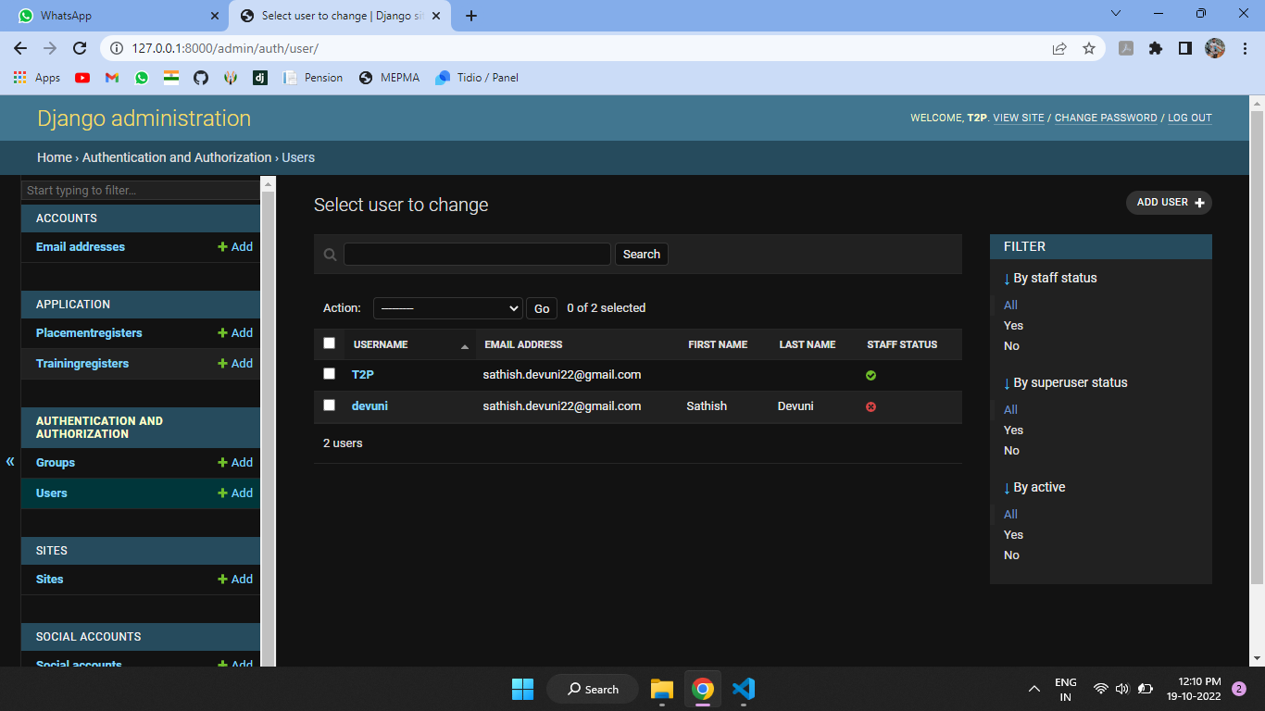

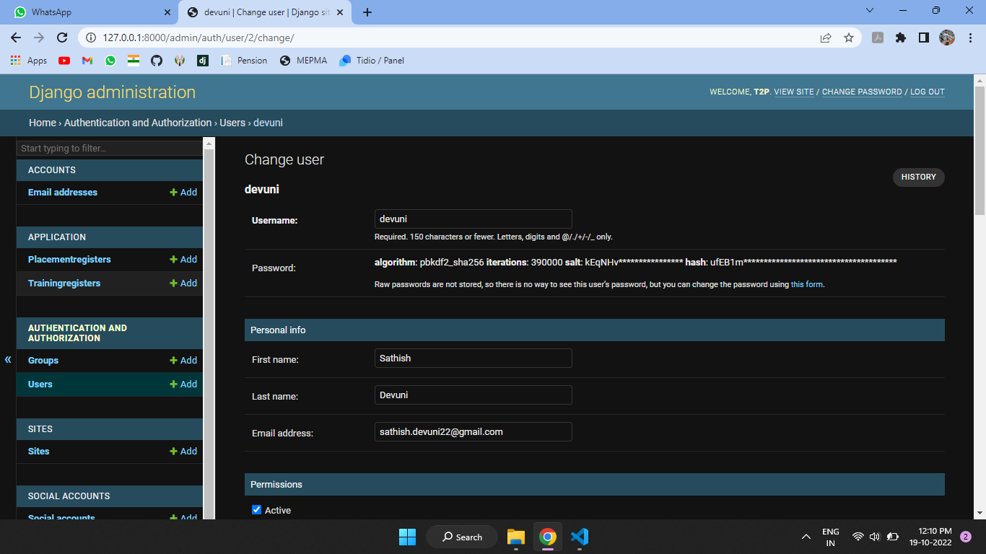

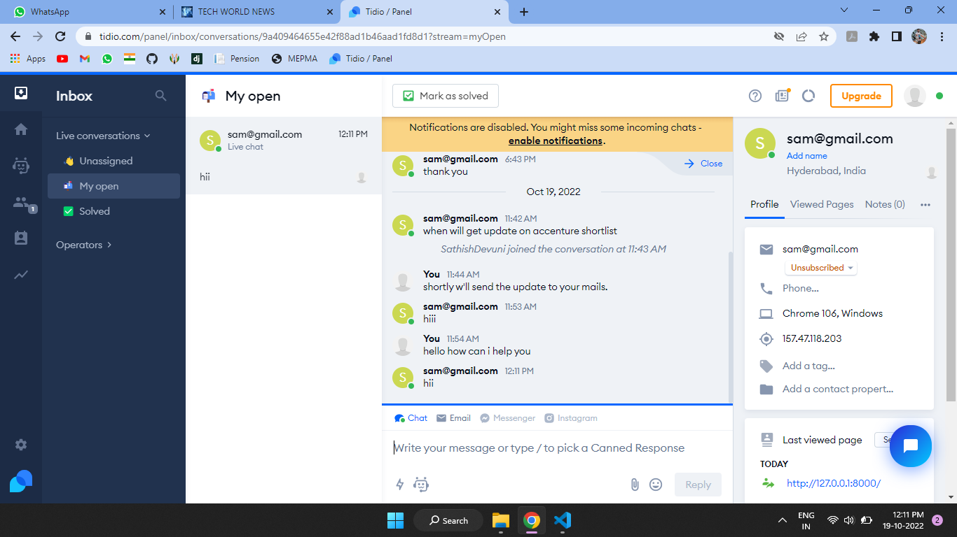

**CHAPTER 5**

**CONCLUSION**

**CONCLUSION**

In the existing system maximum work goes manually and it is error prone system, takes time for any changes in the system. The big problem is the searching and updation of the student data and also no any notification method available for giving information to student expect the notice board.

The proposed online training and placement management system gives the automation in all the process like registration, updating, searching. It provides the detail solution to the existing system problem.

**REFERENCES**

* <https://docs.djangoproject.com/en/4.1/>
* <https://www.tidio.com/panel/dashboard>
* [www.w3schools.com](http://www.w3schools.com/)
* [www.wikipedia.com](http://www.wikipedia.com/)
* [www.tutorialspoint.com](http://www.tutorialspoint.com/)
* <https://docs.python.org/3/c-api/index.html>
* <https://docs.djangoproject.com/en/4.1/ref/contrib/admin/>
* <https://code.visualstudio.com/docs>
* <https://marketplace.visualstudio.com/items?itemName=ms-python.vscode-pylance>